# CS 255 System Design Document

Tyler Pimental

## UML Diagrams

### UML Use Case Diagram

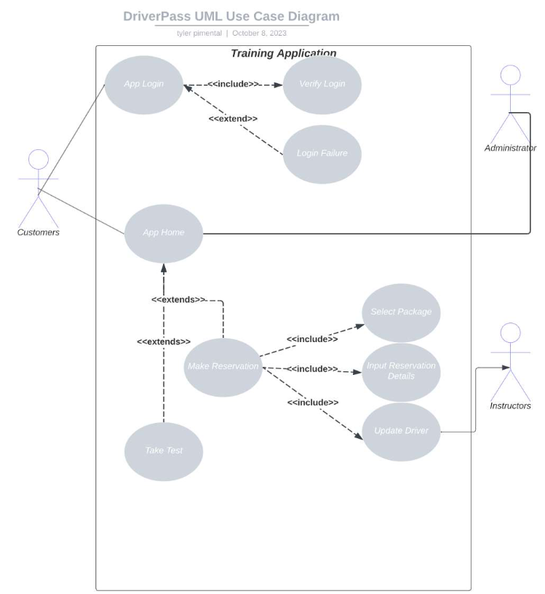

### UML Activity Diagrams

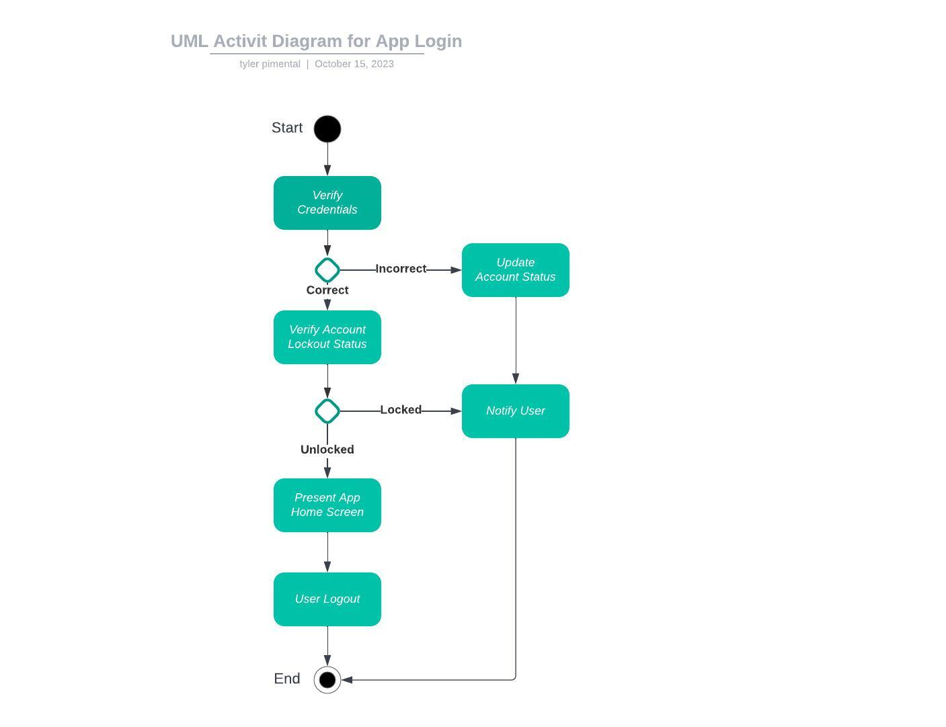

### 

### UML Sequence Diagram

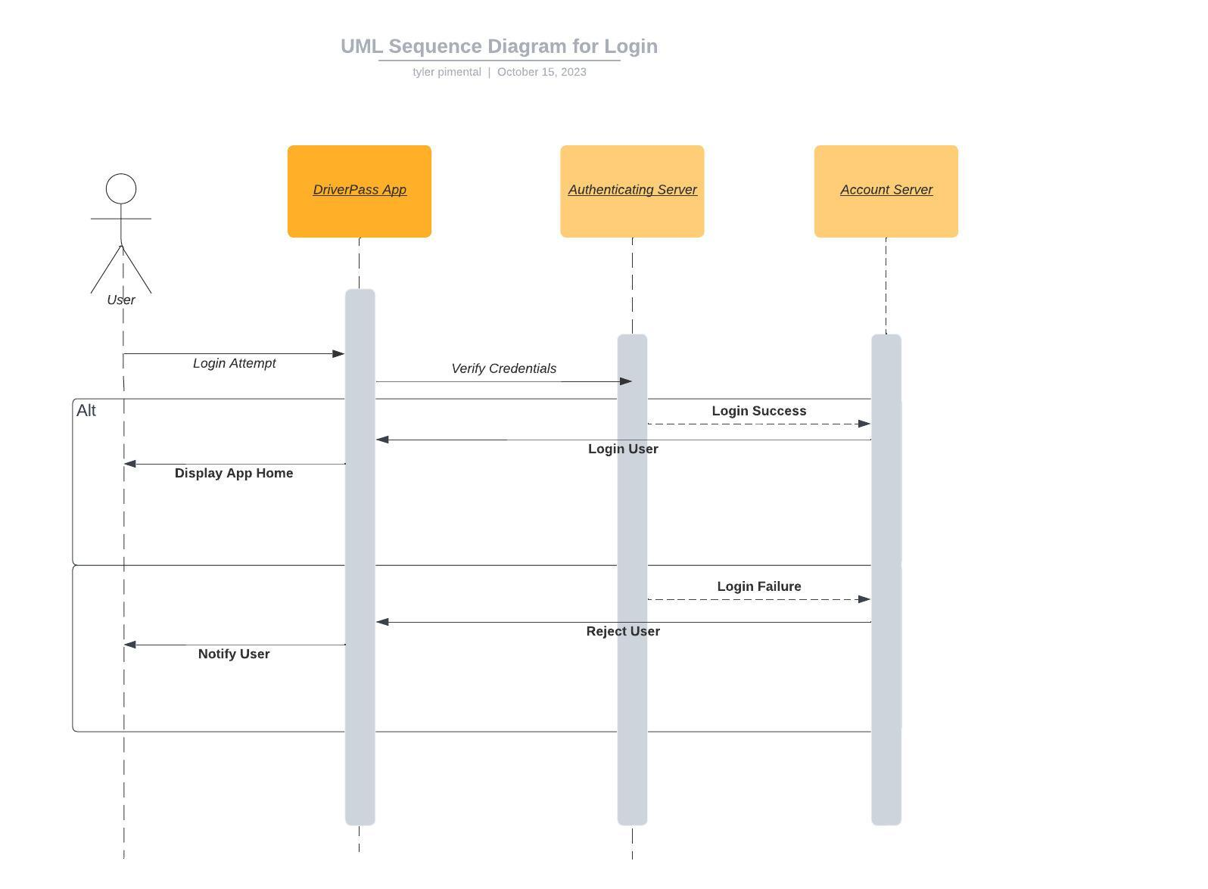

### UML Class Diagram

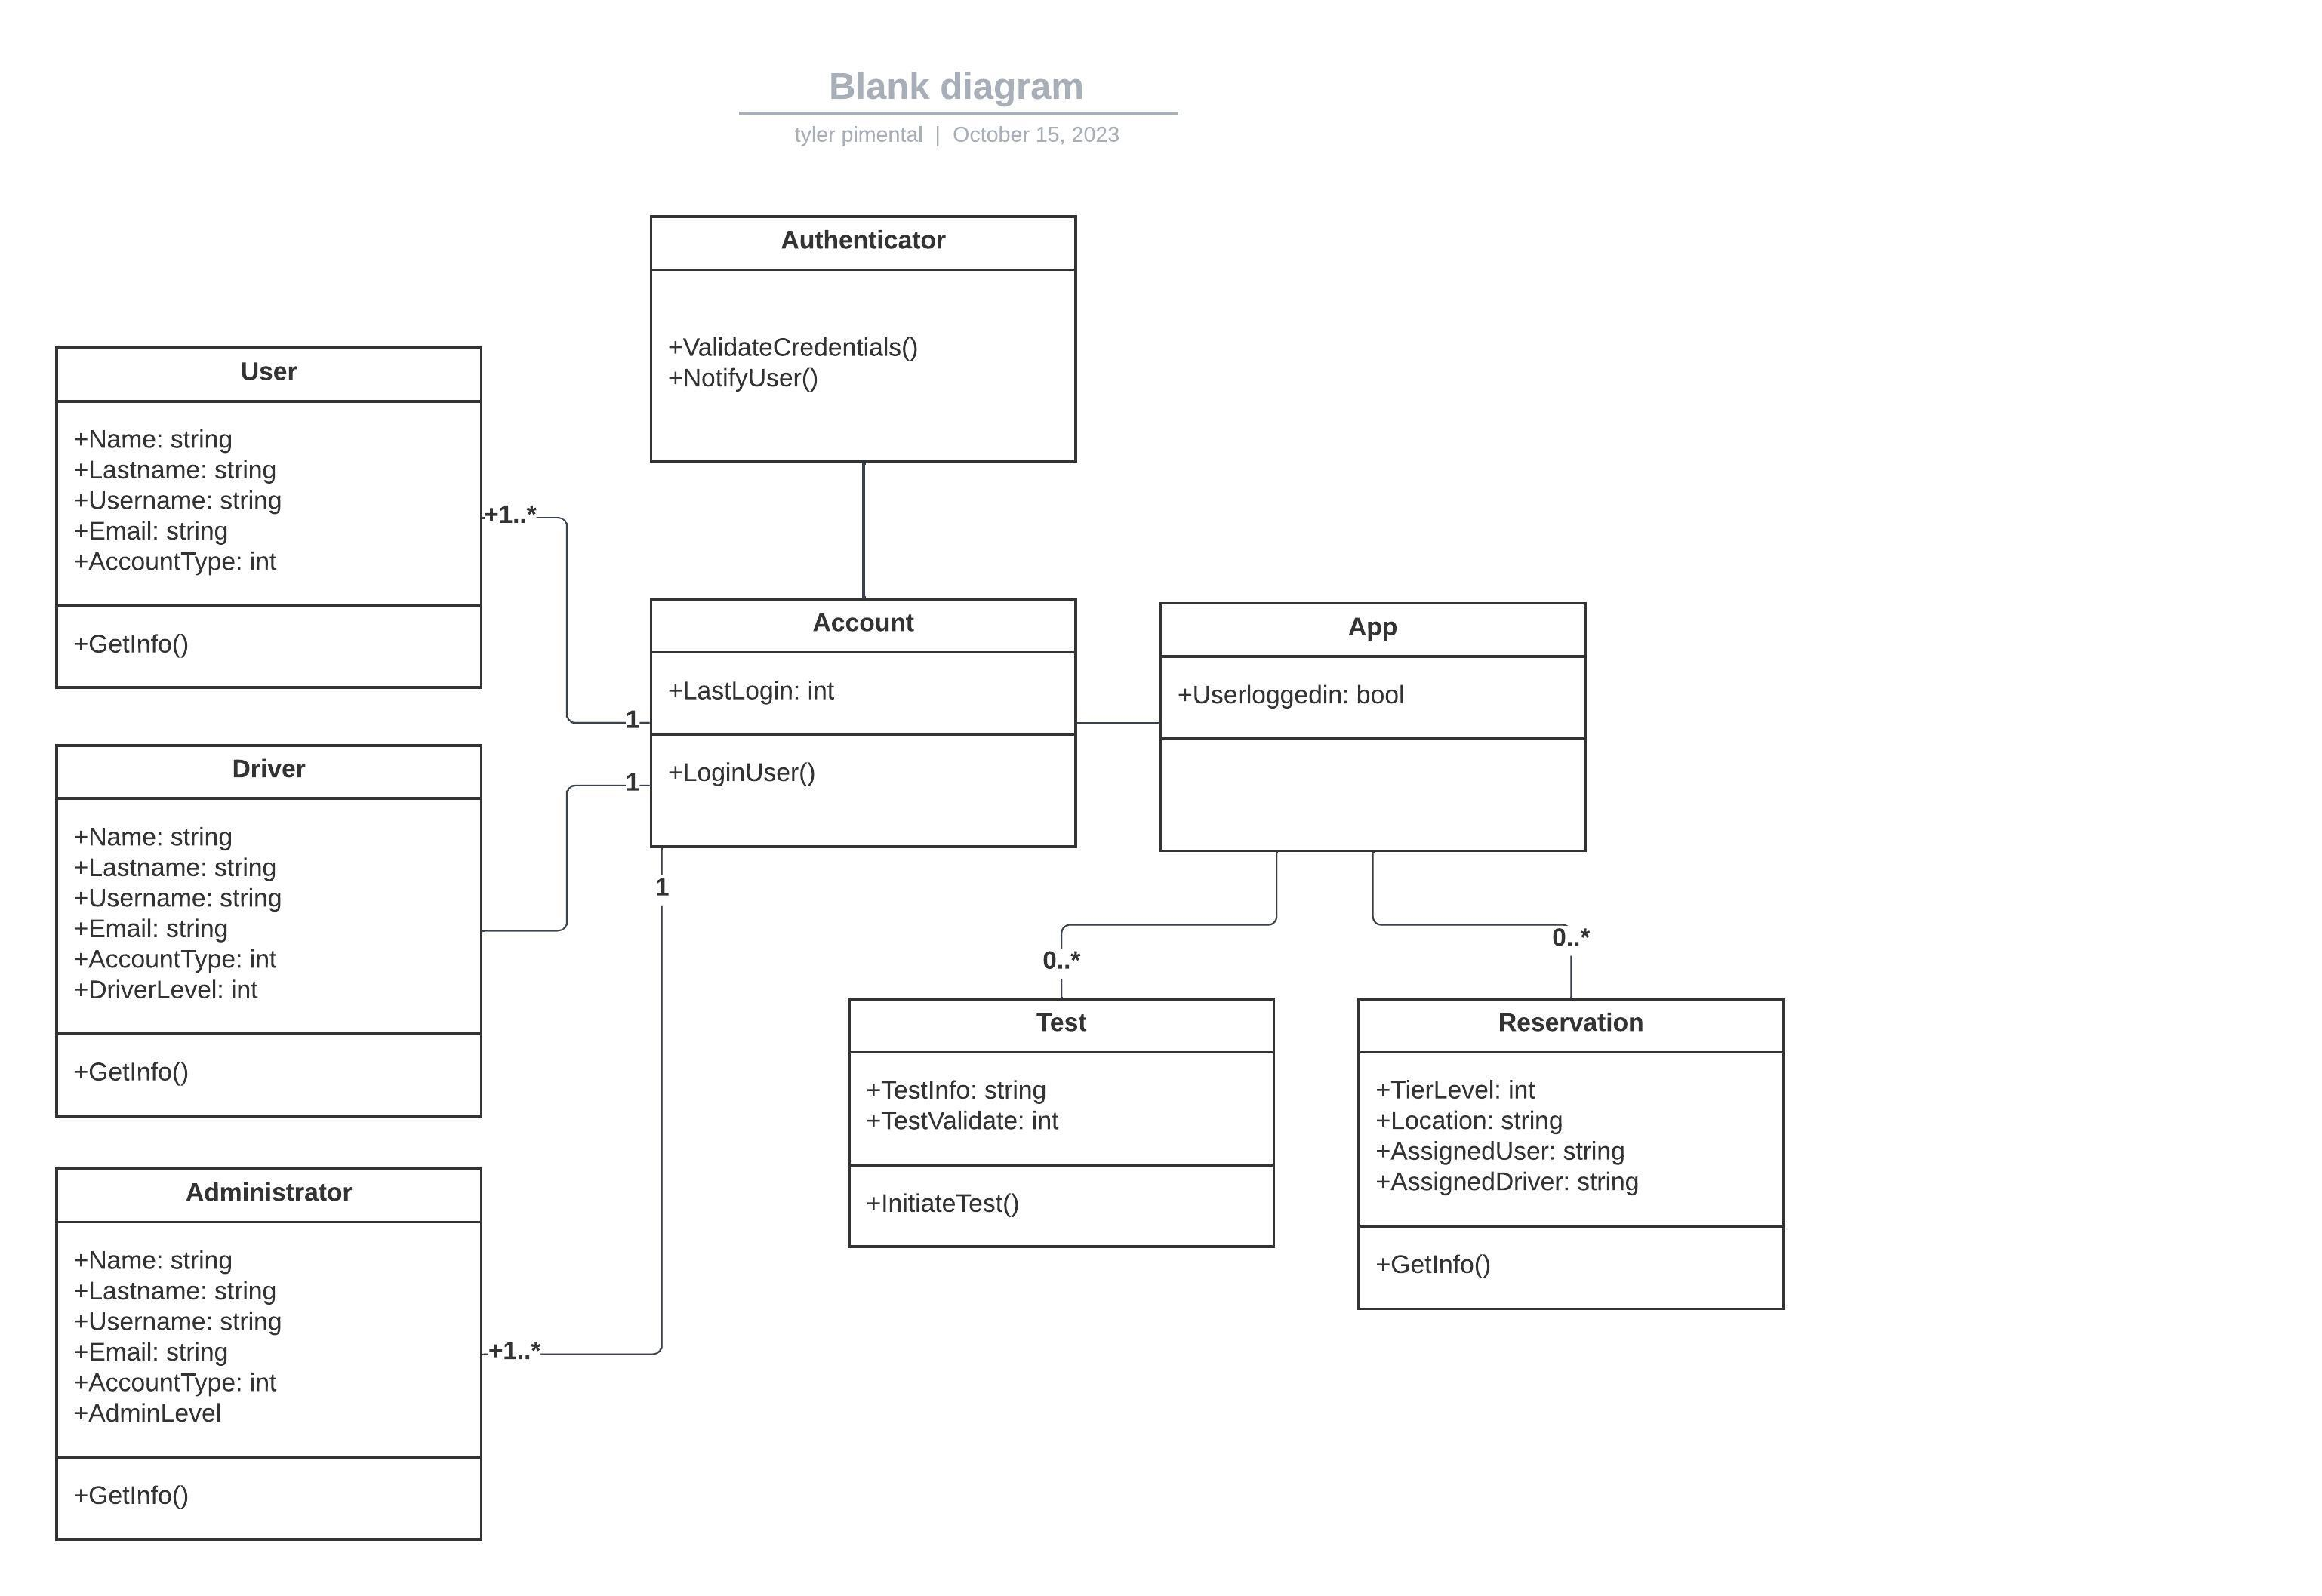

## Technical Requirements

The DriverPass application will be a cloud hosted web application for users to find training through. The application will need to achieve minimal downtime, on the scale of 99.999% uptime, by using failover backend servers in case of disaster. The servers will be configured for elasticity, to accommodate heavy traffic use and to ensure no disruption is seen on the end user's side. A separate authenticating server will need to be in place to handle the Drivers, Users and Administrator logons to the system. The Users and Drivers will connect to a separate database server that will hold information regarding reservations. These reservations will need to be stored and accessed in an industry standard security best practice, preferably using HTTPS. Additionally, transaction logs will be kept to ensure the DriverPass staff can access tracking metrics on the reservations. The operating systems for the servers will utilize Windows and SQL, for their ease of use and practical licensing. Additionally, 3rd party security and backup applications will be in place by the cloud service provider, so the burden is not on DriverPass staff.